**Procedure Room Recording Student Instructions**

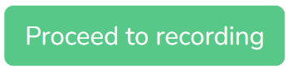

1. Enter your information and click

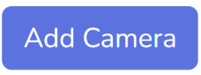

1. Select camera streams to add using the dropdown menu, then click
2. Use the Camera Setups sheet to find recommended orientations for dragging and resizing your camera streams based on the procedure you are completing. Drag and resize camera streams within the recording window as needed.

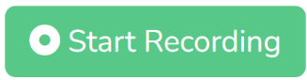

1. Click
2. Replay, delete, and redo your recording as needed.

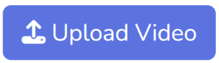

1. Click when you have finished recording. Your recording will be named according to the information you provided earlier and will be made accessible to your facilitator. You're all set!

*Note: The workspace and camera angles should be set up for you already. You can confirm that the camera setup is correct using the Camera Setups sheet.

**Troubleshooting tips:**

* Sound is recorded through the default laptop microphone. If there is no audio when you replay your recording, it may be because you are standing too far from the laptop. Otherwise, have an administrator check system settings to ensure that the laptop microphone is enabled.
* As recordings get longer (>30 minutes), the app may experience some lag. Please be patient!
* If webcams are not being detected while in the recording page, use the back button to return to the landing page. Unplug and plug the webcam back in, then click “Proceed to recording” to check if webcams are detected.
* -If a webcam stream appears black, check to see that nothing is covering the lens. For wireless webcams, ensure that the green WiFi light is on. If not, press the power button.